Connectathon-based Validation Testing for BHITS Interoperability Components
A Springboard to Successful Standards-based Interoperability and HIMSS Showcase Demonstration

Background
The Healthcare Information and Management Systems Society (HIMSS) is a global professional organization that aims to “optimize health engagements and care outcomes through information technology.” HIMSS counts among its members electronic health record (EHR) vendors, hospital information system vendors, healthcare providers, and government agencies. The Office of the National Coordinator for Health Information Technology (ONC) at the Department of Health and Human Services (DHHS) and the ONC’s Federal Health Architecture initiative are actively involved in HIMSS events. HIMSS coordinates closely with health IT and vendor community and provides support for the development of technical frameworks, such as Integration Profiles. Through such efforts, HIMSS guides implementers towards adoption of interoperability standards to address specific business needs.
HIMSS works with the volunteer organization Integrating the Healthcare Enterprise (IHE) to enable the development of Integration Profiles that are organized into domains and promotes the resulting standard-based frameworks as national and international standard adoption guidance.
These IHE Integration Profiles are often referenced by regulation—for example, ONC Meaningful Use criteria related to Edge Protocols. IHE Integration Profiles are typically refined further, as in the Consolidated-Clinical Document Architecture (C-CDA) refinement effort of IHE document templates. They are also reused, as demonstrated by the eHealth Initiative. Through such efforts, HIMSS and IHE Integration Profiles are helping to create a nationwide health information infrastructure. IHE Integration Profiles are the building blocks of health information exchange (HIE) implementations deployed within several states and counties. The profiles support collaboration across Accountable Care Organizations (ACOs), providers, and public agencies.
As a result, any open-source software created by the Substance Abuse and Mental Health Administration (SAMHSA)-supported Behavioral Health Information Technologies and Standards (BHITS) project to enable the reuse of HIEs must demonstrate conformance to the IHE Profiles supported by these standard-based HIEs.
The BHITS project is developing a patient portal called MyHealthCompass. It is an integrated, open-source solution. MyHealthCompass includes an interoperability component called the Information Exchange Hub or IExHub. To be successful, the system must implement specific IHE Integration Profiles and demonstrate conformance to ensure deployment with any standards-based HIE. Figure 1 illustrates the relationships between components.

Figure 1: MyHealthCompass Connects to a Standard-based HIE using IExHub

The Benefits of Connectathon Testing
A Connectathon is a forum for testing conformance that goes beyond one-to-one system testing. It is a cost-effective and objective demonstration of standards conformance and interoperability.
Specifically, the IHE North American Connectathon is a cross-vendor, live, supervised, structured testing event. It involves more than 100 participating vendors, and more than 500 engineers and information technology (IT) architects. The Connectathon employs more than 140 test systems to complete over 4,570 successful tests, facilitated by HIMSS and IHE. The Connectathon is a full week of interoperability testing and problem resolution involving standard-based solutions.
Participants test their products or solutions against multiple vendors (including open-source projects) using real-world clinical scenarios contained in IHE's Integration Profiles. The IHE North American Connectathon works in partnership with the HIMSS Interoperability Showcase. However, it is considered an independent event, requiring a separate registration. The SAMHSA and the BHITS team participated in the 2016 Connectathon on January 25 through 29, 2016, and participated in the HIMSS Interoperability Showcase on March 1 through 3, 2016, under the Federal Health Architecture banner.
Prior to the Connectathon, our team tested the components using several test environments created by the National Institute of Standards and Technology (NIST). This initial round of testing prepared the team well for the live and interactive testing at the Connectathon. By providing these test environments for all vendors to use, NIST plays an important role in pre-Connectathon testing and Meaningful Use certification. Our team will continue to use these tools to ensure conformance.
Besides serving as a springboard to the HIMSS Interoperability Showcase, the IHE Connectathon was also an opportunity to test two key issues: (1) to verify if the IExHub retrieve CDA-encoded document and they can be displayed correctly by MyHealthCompass application display of documents and (2) to ensure interoperability with various PIX, PDQ, and XDS.b-related vendor products that may be deployed by HIEs or used by behavioral health providers.
The Connectathon experience was excellent preparation for real-life deployment. It ensured that any software developed through the BHITS contracts makes effective use of standards to facilitate and lower the cost of integrating behavioral health providers, opioid treatment, prescription drug monitoring programs, and other high-priority SAMHSA initiatives. This effort proves that standard-based open-sources solutions provided by SAMHSA are interoperable standard-based HIE solutions, such as Tiani Spirit, OpenHIE, Philips HSDP, and icoServe.

Outreach to Industry Leaders
The Connectathon is also an opportunity for SAMSHSA and other industry players to promote and adopt standard-based, secure systems that are capable of addressing patients’ privacy concerns. SAMHSA can use the Connectathon to validate that HIEs are capable of leveraging IHE Profiles to protect the privacy of restricted patient records using the criteria outlined in the Data Segmentation for Privacy (DS4P) certification criteria specified by ONC for Meaningful Use 2015.
Privacy-secure systems are becoming a greater priority worldwide. We learned at the Connectathon that implementers in Germany are aware of SAMHSA’s efforts pertaining to 42 CFR Part 2 and have adopted existing IHE Profiles and HL7 Specifications. For instance, they are using a Privacy Consent CDA Implementation Guide instead of the IHE Basic Patient Privacy Consent. These efforts support US policies because SAMHSA helped to develop the standards. This is one example how the Connectathon and other certification efforts bring together like-minded industry participants interested in combining behavioral health information into the continuum of care including:
- Private sector stakeholders—such as HIE and EHR, medical device, and clinical application vendors
- Public sector stakeholders—such as state health departments, opioid treatment programs, the NIST IT Laboratory, the Sequoia Project eHealth Exchange
- Open-source projects—such as openHIE and SMART—to accelerate the adoption of emerging standards
Together, these stakeholder groups have the ability to push the envelope and advance patient privacy protection of electronic records to benefit all patients, not only those protected by specific policies. Therefore a trusted, learning EHR system can be developed to address multiple objectives of improved treatment quality, patient safety, and efficiency.

HIMSS Interoperability Showcase
The HIMSS Interoperability Showcase was an opportunity to demonstrate how patients can be empowered to track and use their healthcare provider and illustrate the continuity of care. The demonstration scenario (Figure 2) focuses on Sally Share, who receives treatment for opioid abuse, asthma, and depression. Her providers submit Sally’s visit summaries to the health information organization (1) using the IHE XDS Registry/Repository. Using the MyHealthCompass application (2), Sally is able access and retrieve her health information from the HIE and to track her methadone dosage, manage her depression, and manage her asthma.
When Sally must travel outside of her area and is unable see her local opioid treatment provider, she creates a consent authorization (3) to allow the HIE to share her information with an alternative provider who will assist Sally in the continuation of her treatment while away. The electronic consent allows her alternative provider to access her opioid dosage information (4), thereby continuing her recovery.
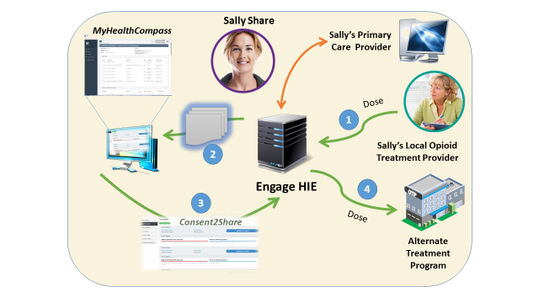
Figure 2: HIMSS Interoperability Showcase Demonstration Scenario

Next Steps: FHIR Based Services as an Abstraction Layer for Application Development
IHE-based integration profiles are based on the Simple Objects Access Protocol (SOAP), a proven solution for XML-based messaging. However, services-based Representational State Transfer (REST), using Hypertext Transfer Protocol (HTTP) has reduced the complexity of messaging protocols, such as ebXML used by IHE ITI XDS.b. This simplification can accelerate the development and deployment of new services. RESTful services are easily implemented by applications and provide an efficient way to deliver business capabilities or resources to application users. For example, Patient Registration as a capability may be provided by a RESTful service. The application can use the Patient service to search, create, or update a Patient Registration. The IExHub invokes the relevant IHE-conformant SOAP services provided by the IHE. HL7 Fast Healthcare Interoperability Resources (FHIR) specification (initially Draft Standard for Trial Use Version 2- DSTU2) defines a set of healthcare-specific RESTful services that are easily implemented by application developers. The semantic consistency between the HIE and application is maintained by the IExHub using a set of standards-based semantic maps based on the concepts in the OMG’s Model-Driven Message Interoperability specification.

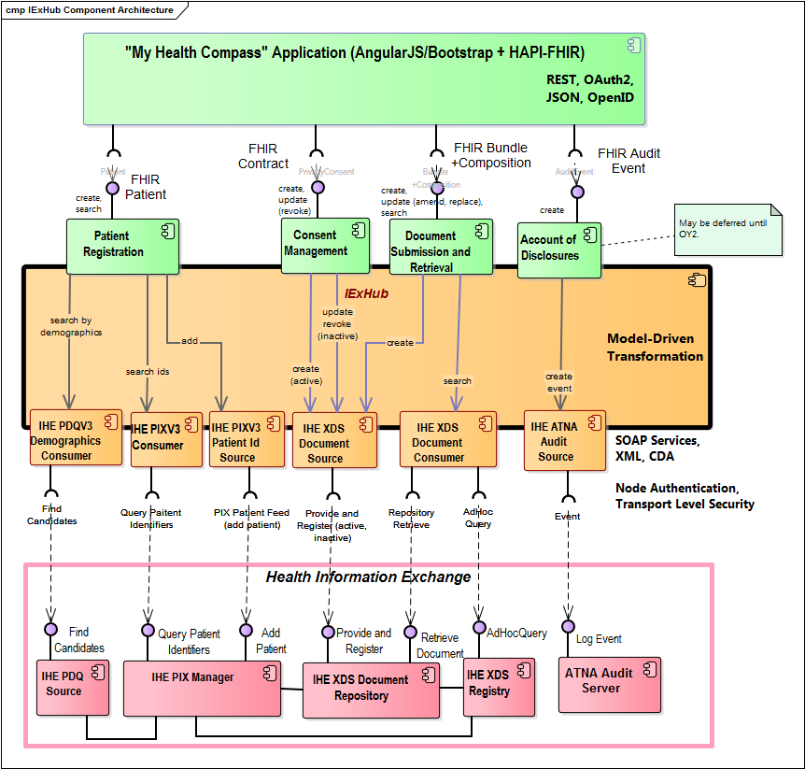
Figure 3: FHIR REST Services can Provide Simple Application Interfaces to Access an HIE
The IExHub supports a set of FHIR resources to enable applications to access HIE functionality:
Patient Registration uses FHIR Patient: allows the application to search for existing patients or add patients to the HIE.
Consent Management uses FHIR Contract: allows the application to create privacy consents and submit them to the HIE as CDA document or other formats as requested.
Next option year:
Document Submission and Retrieval uses FHIR Bundle and FHIR Composition: allows the application to both create and retrieve documents using FHIR resources to populate and decode CDA documents.
Accounting for Disclosures: allows the application to log events related to the disclosure of patient identifiable health information.
FHIR services provide a simple representation of the information exchange by an application with the IExHub. The following structure used to “create” a patient is translated into a PIX “add” payload and exchange using SOAP transaction with an HIE:
Table 1: FHIR Patient resource example
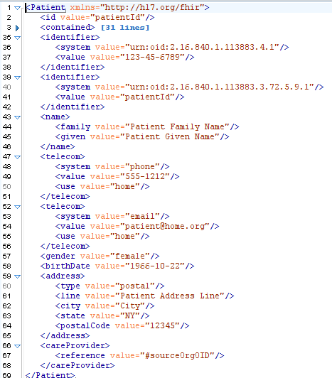

Similarly, the patient’s consent can be created by an application as FHIR Contract resource (both eXtensible Markup Language – XML and Javascript Object Notation – JSON are supported). IExHub leverages the latest/current FHIR specification (DSTU2) and the HAPI FHIR Java library that implements this specification. The HAPI FHIR application programming interface (API) allows application developers to instantiate object and invoke the FHIR RESTful services supported y the IExHub (i.e. FHIR Patient, FHIR Contract, and – in OY2- FHIR Bundle/Composition and FHIR Audit Event)
Table 2: FHIR Contract resource used to represent a basic Privacy Consent
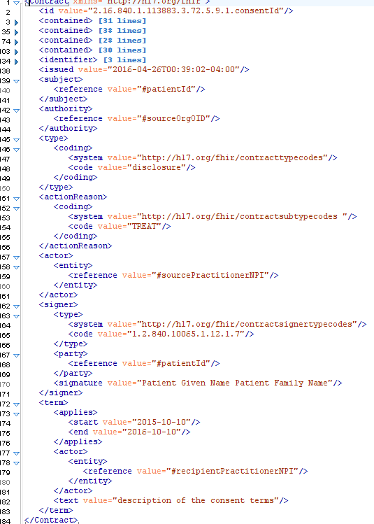

References

IHE NA 2016 Connectathon Results
Table 1 below summarizes the IExHub business requirements and the corresponding IHE Integration Profiles.
Table 3: IExHub Business Requirements and Corresponding IHE Integration Profiles
Requirements Met | IHE Integration Profiles | System Role (Actor)
- Account of Disclosure (audit events logging)  - Node Authentication  - Transport Level Security (TLS) | ATNA - Audit Trail and Node Authentication | Secure Node
- Updates the time across systems  - NTP Time Synchronization | CT - Consistent Time | Time Client
- Search patients by demographic traits  - Support query continuation | PDQV3 - Patient Demographic Query HL7 V3 | PDC - Patient Demographics Consumer  - Query Continuation
- Tested “Add” a local patient id to link it into the affinity domain (HIE)  - “Update” and “Merge” operations initiated by patient are not supported | PIXV3 - Patient Identifier Cross-Reference HL7 V3 | Patient Identity Source  - Patient Registry Record Added (PRPA_IN201301UV02)
- Search/query patient using a local patient id and retrieve  affinity domain identifier  - Confirm local identify matching by retrieving additional identifiers | PIXV3 - Patient Identifier Cross-Reference HL7 V3 | Patient Identifier Cross-reference Consumer
- Retrieve documents (CDA, C-CDA, PDF, etc.), using the local patient identity | XDS.b - Cross-Enterprise Document Sharing | Document Consumer
- Submit/add documents using a local patient identity  - Privacy Consent | XDS.b - Cross-Enterprise Document Sharing | Document Source
System name: GATEWAY_FEI_IExHub_PatientPortal

IHE USA Page

http://iheusa.org/connectathon.aspx
Congratulations to our IHE NA Connectathon 2016 testing participants
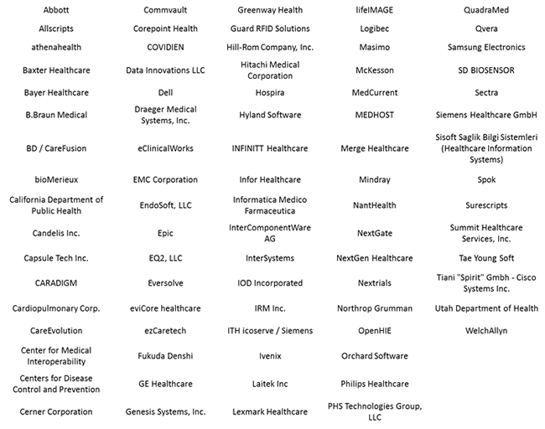
Figure4: Eversolve participated on behalf of SAMHSA/FEi

